**Distance Learning**

**with Mrs. Day**

**Week 4 (April 20th-24th) - DUE April 27th at 9:30 a.m.**

**Required Materials**

We’re continuing with *Animal Farm* this week. If you have a paper book, cool! Alternatively, you can read the whole book here: <http://gutenberg.net.au/ebooks01/0100011h.html>

And you can *listen* to the whole book here:

<https://www.leonschools.net/Page/46276>

**Notes for This Week**

1. I am making this week’s plan on April 9th. That means that a LOT of time will pass between when I publish this plan and when we actually do the tasks. It’s hard to anticipate what will come up between now and then! Please check my website (the front page) for changes and announcements. I will also post class “meeting times” there, so you can join in and do the work with me if you wish!

2. Remember, you can write all of your answers on notebook paper and email me pictures if you like. You can print out this packet and write on it (then email pics). You can copy all of this to a document and “share” it via OneDrive. Or, you can do the whole thing in Teams Assignments. What works for you works for me!

**Week 4 Overview Checklist –**

* **Read Chapter 3 of *Animal Farm***
* **Reading Response Activity (Choice)**
* **Read Chapter 4 of *Animal Farm***
* **Class Chat Posts OR R.E.A.D. Response (Choice)**
* **Covid Crisis Journal #3**
* **Family Game Time - Connections**

**Parent Assignment for Week 3**

* **Give your child a hug, and tell them it’s from Mrs. Day. Tell your child that their teacher loves and cares about them.**
* **Task: Read Chapter 3 of *Animal Farm***
* **Task: Reading Response Activity (Choice)**

**\*Remember that I’ll be reading the chapter AND doing this task with my students (at a time to be determined).**

**Just join the “meeting” in Teams to be part of our class!**

Select **one** of the following assignments to explore the characterization in Chapter 3. If you have an idea for a different reading response, email me and let’s talk about it!

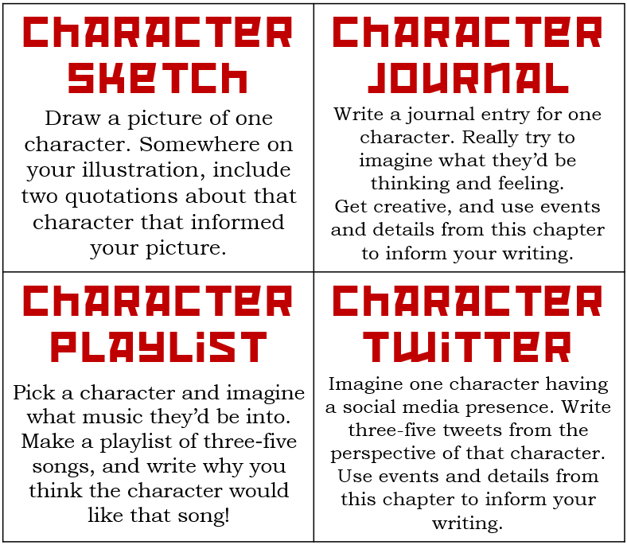

* **Task: Read Chapter 4 of *Animal Farm***
* **Task: Class Chat OR Paragraph Response**

**\*Remember that I’ll be reading the chapter AND doing this task with my students on Thursday at 1:30.**

**Just join the “meeting” in Teams to be part of our class!**

To respond to Chapter 4, we’re going to have a class discussion in Teams. Log in and post **at least two** responses in our class period’s chat. You can answer my posted questions, or ask your classmates new ones. For full credit, your posts must be thoughtful and should demonstrate your understanding of the text.

**OR…**

Write a R.E.A.D. paragraph to answer the following prompt. Why is “Beasts of England” a song that so many animals love? What is it about the song that the animals respond to, even outside of Animal Farm? Remember to **R** – Restate AND Answer the Question, **E** – Evidence from the Text (to prove your answer), **A** – Analysis/Evaluation of your evidence, and **D** – Draw Conclusions (wrap up/conclude your paragraph).

________________________________________________________________________________________________________________________________________________________________________________________________________________________________

________________________________________________________________________________________________________________________________________________________________________

* **Task: Covid Crisis Journal #3**

Remember, you don’t **have** to answer my prompt. If you wish, you may simply write a paragraph (five-seven sentences) about what you’re thinking, doing, reading, feeling, or experiencing (etc.) during this moment in history.

**Prompt #3 – Let’s talk about good stuff! What is bringing you comfort during this time? What do you like about being at home? What are you looking forward to? In short, what’s good?**

________________________________________________________________________________________________________________________________________________________________________________________________________________________________

________________________________________________________________________________________________________________________________________________________________________

* **Task: Family Game Time – *Connections***

Below, you’ll find a table with sixteen clues in it. Your mission is to sort those clues into four categories, and then name the categories. Be careful, clues might seem to fit in more than one category, or seem to fit into a different, extra, category. There is only one perfect solution.

Mrs. Day will pull three names from the correct answers, and mail those three winners prizes!

|  |  |  |  |
| --- | --- | --- | --- |
| well | fare | smith | so |
| curtain | chop | chow | tide |
| cooper | dough | ford | knock |
| depp | nosh | grub | phoenix |

**Categories**

___________ ____________ ____________ ___________

1._________ 1.__________ 1.__________ 1._________

2._________ 2.__________ 2.__________ 2._________

3._________ 3.__________ 3.__________ 3._________

4._________ 4.__________ 4.__________ 4._________